Description of Exam One - 100 points - 75 Minutes
Multiple Choice: 26 points
- 13 questions at 2 points each
- 15 minutes

Sentence Revision: 16 points
- 4 questions at 4 points each
- 15 minutes

Sentence Creation: 16 points
- 4 questions at 4 points each
- 15 minutes

Sentence Diagrams: 42 points
- 3 diagrams and labeling at 14 points each
  - 7 pts for each labeling table
  - 7 pts for each diagram
- 20 minutes

Section A: Multiple Choice (26 points)
Question One (2 pts):
Which of these sentences contains a noun phrase (form) serving as an adverbial (function)?
- This summer, she plans to graduate.
- Summer is her favorite season.
- Monday morning feels the longest.
- My brother likes winter.
Answer: _______________________
Question Two (2 pts):
Which of the following sentences contains an infinitive phrase (form) serving as an adverbial (function)?
- To stay healthy, he exercises daily.
- He exercises to the rhythm of the music.
- I don’t enjoy jogging.
- He exercises, hoping to stay fit.
Answer: _______________________
Question Three (2 pts):
Which of the following sentences contains a present participial verb phrase (form) serving as an adverbial (function)?
- Singing loudly annoys my neighbor.
- Singing loudly, she finished her chores quickly.
- You are singing too loudly.
- They dislike singing loudly.
Answer: _______________________
Question Four (2 pts):
Which of the following sentences uses a past participial verb phrase (form) as an adjectival (function)?
- The cookies baked this morning smell delicious.
- I baked the cookies this morning.
- The cookies that were baked smell delicious.
- The cookies will bake soon.
Answer: _______________________
Question Five (2 pts):
Which of the following sentences uses a present participial verb phrase (form) as an adjectival (function)?
- The students studying in the library are focused.
- The students are studying in the library today.
- I remember studying in that library.
- They finished studying early.
Answer: _______________________
Question Six (2 pts):
Which of the following sentences uses a present participle verb phrase (form) as a nominal (function)?
- I skipped breakfast.
- I am skipping breakfast.
- Skipping breakfast affects my energy.
- The person skipping breakfast looks tired.
Answer: _______________________
Question Seven (2 pts):
Which of the following sentences uses an infinitive verb phrase (form) as a nominal (function)?
- To travel abroad is my dream.
- I saved money to travel abroad.
- We will travel abroad soon.
- I like people who travel abroad.
Answer: _______________________
Question Eight (2 pts):
Which of these best describes the underlined portion?
Sentence: The clothes neatly folded by the clerk were placed on the top shelf.
- A relative clause serving as an adjectival
- An appositive serving as an adjectival
- A present participle verb phrase serving as an adjectival
- A past participle verb phrase serving as an adjectival
Answer: _______________________
Question Nine (2 pts):
Which of these best describes the underlined portion?
Sentence: The clothes that the clerk neatly folded were placed on the top shelf.
- A relative clause serving as an adjectival
- A complement clause serving as an adjectival
- A present participle verb phrase serving as an adjectival
- A past participle verb phrase serving as an adjectival
Answer: _______________________
Question Ten (2 pts):
Which of these best describes the underlined portion?
Sentence: The clothes had been carefully folded to avoid wrinkling.
- A relative clause serving as an adverbial
- A complement clause serving as an adverbial
- A prepositional phrase serving as an adverbial
- An infinitive verb phrase serving as an adverbial
Answer: _______________________
Question Eleven (2 pts):
Which of these best describes the underlined portion?
Sentence: She realized that her best friend had moved away.
- A relative clause serving as a direct object
- A complement clause serving as a direct object
- A noun phrase serving as a direct object
- A past participle verb phrase serving as a direct object
Answer: _______________________
Question Twelve (2 pts):
Which of the following sentences contains a complement clause?
- Mia bought a car and drove it across the country.
- Mia decided where she would drive her new car.
- Mia loved the feeling of driving across the country.
- Mia was excited by the journey.
Answer: _______________________
Question Thirteen (2 pts):
Which of these sentences contains a relative clause?
- I will greet that neighbor today.
- That neighbor waved at me.
- I will thank whomever helped me.
- I will thank the neighbor who helped me.
Answer: _______________________

Section B: Sentence Revision (16 points)
Question Fourteen (4 pts):
Combine these two sentences by transforming one into a relative clause.
- The song topped the charts.
- The song was written by a local artist.
- The song that topped the charts was written by a local artist.

Question Fifteen (4 pts):
Combine these two sentences by transforming one into a complement clause.
- She discovered that you lied about the event.
Question Sixteen (4 pts):
Combine these two sentences by transforming one into a past participial verb phrase serving as an adjectival.
- The door was broken – forced open by the storm.
- The door was forced open during the storm.
- The broken door was forced open during storm.
- The door, that was forced open during the storm, was broken.
Question Seventeen (4 pts):
Revise this sentence to include a present participle verb phrase in the subject position.
- My hobby is to collect comic books.
- Collecting comic books is my hobby.

Section C: Sentence Creation (16 points)
Instructions: Choose a movie, TV show, or book you like. Write each sentence about the movie, TV show, or book you choose. Name it here: _________________________________
Question Eighteen (2 pts):
Write a sentence containing a dependent clause connected with a subordinating conjunction.
- Dean was the mean one while Sam was the kind one.

Question Nineteen (2 pts):
Write a sentence containing a relative clause.
- Castiel, who loved the Winchester, prioritized humans over angels.

Question Twenty (2 pts):
Write a sentence containing a complement clause.
- Walter feared that Gustavo was going to kill him.

Question Twenty One (2 pts):
Write a sentence containing a verb phrase (form) serving as a noun phrase (function).
-

Section D: Sentence Diagrams and Labeling Tables (42 points)
For each sentence:
- Complete the labeling table (7 points)
- Draw the tree diagram (7 points)
Question Twenty Two (14 pts):
Sentence: The student who studies late needs to drink coffee every morning.
Twenty Two Part A: Complete the Labeling Table below.
CLAUSE | Main |  | Relative |  |  | Main
ROLE | Subj |  | Adjl |  |  | Pred | Direct Object |  |  | Advl
PHRASE | NP |  | -- | VP |  | VP | VP |  | NP | NP
WORD | The | Student | Who | Studies | Late | Needs | To Drink | Coffee |  | Every | Morning
Part of Speech | Det | N | Rel | V | Adv | V | V | N |  | Det | N

Twenty Two Part B: Diagram this sentence
Sentence: The student who studies late needs to drink coffee every morning.
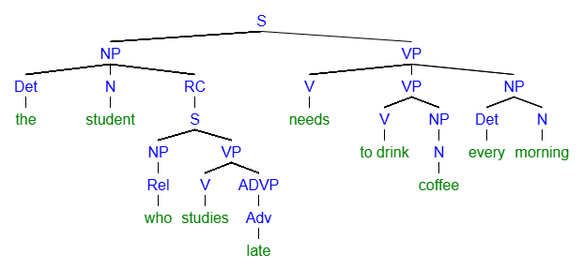
[S [NP [Det the] [N student] [RC [S [NP [Rel who]] [VP [V studies] [ADVP [Adv late]]]]]] [VP [V needs] [VP [V to drink] [NP [N coffee]] [NP [Det every] [N morning]
Question Twenty Three (14 pts):
Sentence: Learning new language can be helpful if you travel.
Twenty Three Part A: Complete the Labeling Table below.
CLAUSE | Main/Independent |  |  |  |  |  | Dependent
ROLE | Subj |  |  | Pred |  | Subj Comp | --- | Subj | Pred
PHRASE | VP | NP |  | VP |  | ADJP | --- | NP | VP
WORD | Learning | New | Languages | Can | Be | Helpful | If | You | Travel
Part of Speech | V | Adj | N | Mod | V | Adj | Sub | Pro | V

Twenty Three Part B: Diagram this sentence
Sentence: Learning new language can be helpful if you travel.
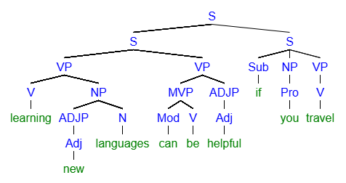
[S [S [VP [V learning] [NP [ADJP [Adj new]] [N languages]]] [VP [MVP [Mod can] [V be]] [ADJP [Adj helpful]]]] [S [Sub if] [NP [Pro you] [VP [V travel
Question Twenty Four (14 pts):
Sentence: Sherlock knows where the treasure is hidden and who buried it.
Twenty Four Part A: Complete the Sentence Labeling Table below.
CLAUSE | Main |  | Complement Clause One |  |  |  |  | --- | Complement Clause Two
ROLE | Subj | Pred | Direct Object |  |  |  |  | -- | Direct Object
PHRASE | NP | VP | --- | NP |  | VP |  | -- | NP | VP | NP
WORD | Sherlock | Knows | Where | The | Treasure | Is | Hidden | And | Who | Buried | It
Part of Speech | N | V | Comp | Det | N | Aux | V | Conj | Comp | V | Pro

Twenty Four Part B: Diagram this sentence.
Sherlock knows where the treasure is hidden and who buried it.
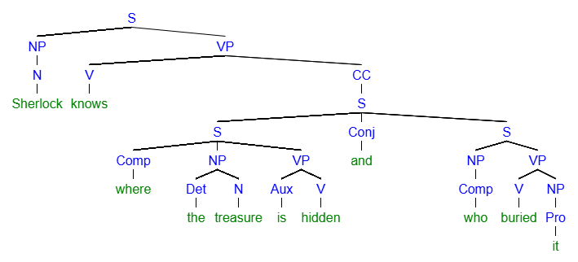
[S [NP [N Sherlock]] [VP [V knows]] [CC [S [S [Comp where] [NP [Det the] [N treasure]] [VP [Aux is] [V hidden]]] [Conj and] [S [NP [Comp who] [VP [V buried] [NP [Pro it]

